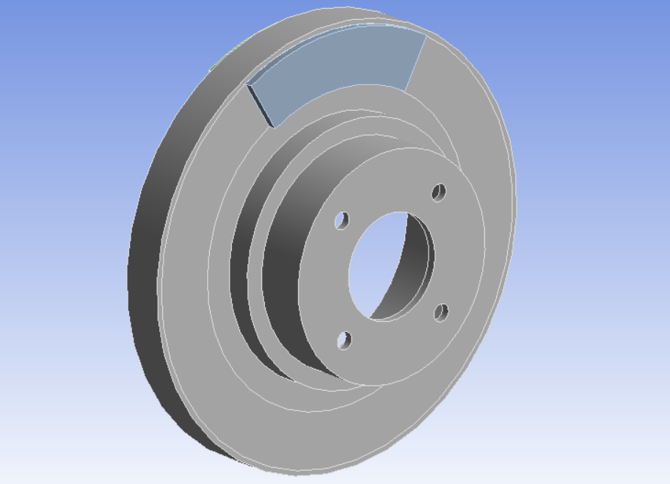

Optimization of a Disc Brake System

MAE598

David Wittman

## Model Analysis

The main model of the system consists of a rotor that is spinning at high speeds. This is the most common method (besides drum brakes) for stopping moving vehicles. Both sides of the disk are a smooth surface that interface with arc shaped pads that use friction to stop the spinning wheels of the moving vehicle. With friction comes both heat and a potential for a mixture of both dynamic and static, causing potential for failure due to resonance. The scope of this model covers only the transient thermal, modal, and structural analyses within FEA software.

In this scope, we are limited to ANSYS and the power provided by the somewhat limited toolset. Throughout will be outlined how the rotor will be optimized to reduce overall volume using common optimization techniques.

## 1.1 Structural Analysis

The structural system consists, as outlined above, a total of three components. The rotor is assumed as structural steel, while the brake pads are assumed as cast iron. When braking, the pads squeeze the rotor. This force has been estimated as a $1.0495 {10}^{7}Pa$ of both brake pad on each side of the rotor. In addition, it is assumed that the rotor is rotating at $250\frac{rad}{sec}$ which is around $2400 RPM$. From this, if we consider the most common tire diameter (17 in), we can see that the speed is around $60 mph$, another common speed on highways/state routes. From that simple calculation it is confirmed that this model may be representative of real-life conditions, still within the project scope. The initial diameter of the rotor is 250mm in diameter, initial thickness of $25mm$, and total rotor diameter of $9.967 {10}^{5} {mm}^{2}$. The coefficient of friction of the brake pads are .2. This means that 20 percent of the force acting normal to the surface acts tangential to the surface with a frictional force.

Using Von-Mises criteria, it is found that the maximum stress is $1.4299 {10}^{7}Pa$. This is one of three parameters that will be used in the Design of Experiments.

## 1.2 Modal Analysis

Modal Analysis is often overlooked by those unfamiliar with vibration and resonance. Resonance is the passive vibrational frequency of an object. When fastening components that carry vibrational modes, it can be very common for failure to occur with little to no evidence as to the failure mode. For the minor deformations created by these vibrations shown below:

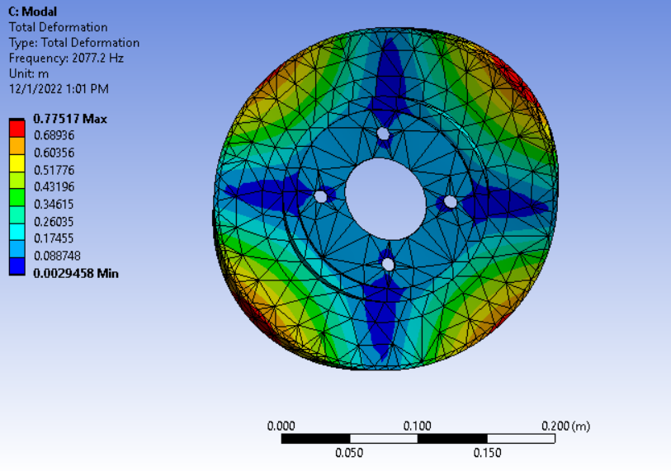

From above, the maximum deformation is shown as $7.78 {10}^{-1}m$ which is significant when rotating at 2400 RPM.

## 1.3 Thermal Analysis

The thermal analysis evaluates the heating of the rotor due to frictional force from the pad. Here we can simulate the brake pad on the rotor using the heat flux thermal solution tool. Between both this and the convective cooling on the rotor during braking leaves the result:

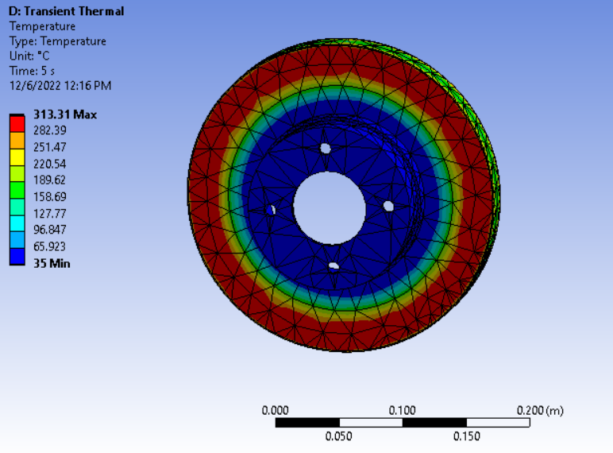

The maximum temperature due to the heat flux will be a design parameter when the DoE is constructed and the Response Surface is generated.

## Optimization

## 2.1 Design of Experiments

Post-initialization of all applicable models, the parameters pulled from past analyses will be acting as design variables in the design of experiments section of analysis. The design of optimization will be fed into ANSYS optimization methods. In ANSYS, the Design of Experiments method used is Latin Hypercube Sampling with a user input amount of samples. This is the recommended method as it is the most efficient and will not take a significant amount of time for the parameters to be calculated. Below is a table outlining the bounds of the parameters. These bounds exist to prevent ANSYS from evaluating dimensions that are undefined (i.e., The rotor not coming into complete contact with the brake pad). The Brake pad is radially 32mm, so this defines the difference between the inner and outer diameters to evaluate to less than or equal to this minimum value. In addition to this idea, ANSYS may not evaluate a particular combination of parameters and within the span of this project, those data points will not be evaluated. These parameters are based on the interferences between the dimensions of the rotor:

|  |  |  |  |
| --- | --- | --- | --- |
| Parameter | Rotor Thickness (mm) | Outer Diameter (mm) | Inner Diameter (mm) |
| Minimum Value | 10 | 125 | 70 |
| Maximum Value | 30 | 150 | 85 |

Note: While the input to the Design of Experiments is discrete, the parameters are very much continuous within the boundaries.

## 2.2 Response Surface

The Response Surface of the model is created using the parameter set from the Design of Experiments. Within the Response Surface, multiple response surface types are available for usage. In this, the most recommended generation type is neural network. This method keeps computation low when compared to other methods, but the tradeoff is in training the network, which may require multiple iterations and may generate different results after every iteration. In general, a direct fit through the data set is unnecessary thus this method is the most applicable. Below are the results with the most optimal designs. Additionally, the candidate design has been verified using the verification toolkit in ANSYS. Here are the resulting graphs of the sensitivity analysis:

Above we can see the thickness plays the largest role in affecting the other parameters. It is additionally shown that no parameters are monotonic.

Below we can see the bounds of our sensitivities. This figure illustrates the proximity of the design points and how the change in them (right or left) can affect the others. These results show us that the initial range of parameters are all within the optimal range of the optimization algorithm. Had our design points been on curves that are vertically distant from another, this would be a good indicator to go back and modify the parameters within the constraints of the project to within a range that all curves are the closest possible. The potential tradeoffs are severe on all the other outputs from the value of the thickness alone.

Below is the Predicted vs. Normalized graph. This figure is comparing the design points from the parameter set to the verified points in the response surface 50 design points were constructed with 5 verification points.

## 2.3 Optimization

The optimization technique is the MOGA (Multi-Objective Generic Algorithm). This is vey useful in accounting for multiple objectives and constraints. Here we searching to minimize the overall volume of the rotor, the total stress of the rotor, the maximum temperature, while maximizing the 7th mode of deformation in Hz. Below are the results of the analysis

|  |  |  |  |  |  |  |  |
| --- | --- | --- | --- | --- | --- | --- | --- |
| Candidate | ID (mm) | OD (mm) | Thickness (mm) | Max Stress (Pa) | Temp (C) | Deform. (Hz) | Vol. (mm­3) |
| DP 1 | 79.502 | 127.63 | 15.841 | 1.0831E +07 | 370.03 | 1415.5 | 7.5 E -04 |
| DP 1 (verified) | 1.1250E +07 | 370.63 | 1415.4 |
| Original | 75 | 125 | 25 | 1.4299E +07 | 310.52 | 2045.8 | 9.9E -04 |

This optimized design features the smallest possible volume obtainable within the parameter bounds. The sensitivity analysis from above shows that the design is within the correct bounds. Looking more into the realism of brake design and what is common among those designs, one can see that standard brakes operate at much lower temps (315 for standard brakes). This leads one to further optimize the design and see if the optimizer is capable of a more sophisticated design that is more reflective of reality. Here is the updated data with a new constraint maximum on the temperature rather than a minimization objective.

|  |  |  |  |  |  |  |  |
| --- | --- | --- | --- | --- | --- | --- | --- |
| Candidate | ID (mm) | OD (mm) | Thickness (mm) | Max Stress (Pa) | Temp (C) | Deform. (Hz) | Vol. (mm­3) |
| DP 1 | 84.9 | 125.07 | 21.788 | 1.206E +07 | 318.93 | 1386.8 | 8.5 E -04 |
| DP 1 (verified) | 1.196E +07 | 323.4 | 1375.7 |
| Original | 75 | 125 | 25 | 1.4299 +07 | 310.52 | 2045.8 | 9.9E -04 |

Below is the geometry derived from the optimization. It is very similar to the geometry of the original but features a volume decrease of 14%, a substantial amount considering at least two will be present on the vehicle at all times. Depending on the circumstances, the optimization can be adjusted accordingly. An example would be that the minimum diameter may need to be a certain size in order to fit on the wheel, or the designer may not need the maximum stress, as long as the part does not fail. Both of these parameters could be transitioned into constraints and would free the designer to focus on the rotor and brake pad not friction welding under much higher temperatures.

## Conclusion

To conclude, the rotor and brake pad system has been optimized to minimize volume while also keeping the other parameters within a physically realistic range. While this optimization initially created results that were a much larger decrease in overall volume, one must think about the entire lifespan of the part that is being designed. Many parts contain a daunting number of parameters, and it is the engineer’s responsibility to model the system in parallel with reality.